Joel Atkinson
February 21, 2026
CSD430 Server Side Development
Assignment 8.2
Project Part 3

Updated JavaBean Code:
package beans;
import java.sql.*;
import java.util.ArrayList;
import java.util.List;
/* Joel Atkinson, February 20, 2026 CSD430 Server Side Development Assignment Part 3 UPDATED BEAN CODE
The purpose of this assignment is to create a database called CSD430 in SQL, then create a table (I chose U.S. states),
and populate that table with at least 5 data fields. From there create a JavaBean to pull the data from the database
which will be linked to the .jsp files in order to have a selection of a U.S. state and then to display the data of that
state in a table. In addition to this, also create an index.jsp file for this course as the landing page where all of our
assignments will be held. I went ahead and also created .css style sheets for both the index as well as the module 5/6
.jsp files. */
public class StatesBean {
private static final String JDBC_URL = "jdbc:mysql://localhost:3306/CSD430?useSSL=false&serverTimezone=UTC";
private static final String JDBC_USER = "student1";
private static final String JDBC_PASS = "pass";
private static final String JDBC_DRIVER = "com.mysql.cj.jdbc.Driver";
static {
try {
Class.forName(JDBC_DRIVER);
} catch (ClassNotFoundException e) {
e.printStackTrace();
}
}
private Connection getConnection() throws SQLException {
return DriverManager.getConnection(JDBC_URL, JDBC_USER, JDBC_PASS);
}
public static class StateOption {
public final int id;
public final String name;
public StateOption(int id, String name) {
this.id = id;
this.name = name;
}
}
public static class StateRecord {
public int id;
public String stateCode;
public String stateName;
public String capital;
public String region;
public Long population;
public Integer yearFounded;
}
public List<StateOption> getStateOptions() {
List<StateOption> options = new ArrayList<>();
String sql = "SELECT id, state_name FROM Joel_states_data ORDER BY state_name";
try (Connection conn = getConnection();
PreparedStatement ps = conn.prepareStatement(sql);
ResultSet rs = ps.executeQuery()) {
while (rs.next()) {
options.add(new StateOption(
rs.getInt("id"),
rs.getString("state_name")
));
}
} catch (SQLException e) {
e.printStackTrace();
}
return options;
}
public StateRecord getStateById(int id) {
String sql = "SELECT id, state_code, state_name, capital, region, population, year_founded " +
"FROM Joel_states_data WHERE id = ?";
try (Connection conn = getConnection();
PreparedStatement ps = conn.prepareStatement(sql)) {
ps.setInt(1, id);
try (ResultSet rs = ps.executeQuery()) {
if (rs.next()) {
StateRecord s = new StateRecord();
s.id = rs.getInt("id");
s.stateCode = rs.getString("state_code");
s.stateName = rs.getString("state_name");
s.capital = rs.getString("capital");
s.region = rs.getString("region");
long popVal = rs.getLong("population");
s.population = rs.wasNull() ? null : popVal;
int yf = rs.getInt("year_founded");
s.yearFounded = rs.wasNull() ? null : yf;
return s;
}
}
} catch (SQLException e) {
e.printStackTrace();
}
return null;
}
public List<StateRecord> getAllStates() {
List<StateRecord> states = new ArrayList<>();
String sql = "SELECT id, state_code, state_name, capital, region, population, year_founded " +
"FROM Joel_states_data ORDER BY state_name";
try (Connection conn = getConnection();
PreparedStatement ps = conn.prepareStatement(sql);
ResultSet rs = ps.executeQuery()) {
while (rs.next()) {
StateRecord s = new StateRecord();
s.id = rs.getInt("id");
s.stateCode = rs.getString("state_code");
s.stateName = rs.getString("state_name");
s.capital = rs.getString("capital");
s.region = rs.getString("region");
long popVal = rs.getLong("population");
s.population = rs.wasNull() ? null : popVal;
int yf = rs.getInt("year_founded");
s.yearFounded = rs.wasNull() ? null : yf;
states.add(s);
}
} catch (SQLException e) {
e.printStackTrace();
}
return states;
}
public boolean addStateRecord(String stateName,
String stateCode,
String capital,
String region,
Long population,
Integer yearFounded) {
String sql = "INSERT INTO Joel_states_data " +
"(state_name, state_code, capital, region, population, year_founded) " +
"VALUES (?, ?, ?, ?, ?, ?)";
try (Connection conn = getConnection();
PreparedStatement ps = conn.prepareStatement(sql)) {
ps.setString(1, stateName);
ps.setString(2, stateCode);
ps.setString(3, capital);
ps.setString(4, region);
if (population == null) {
ps.setNull(5, Types.BIGINT);
} else {
ps.setLong(5, population);
}
if (yearFounded == null) {
ps.setNull(6, Types.INTEGER);
} else {
ps.setInt(6, yearFounded);
}
return ps.executeUpdate() == 1;
} catch (SQLException e) {
e.printStackTrace();
return false;
}
}
//Updated portion of Java Bean for Part 3 of assignment
public boolean updateStateRecord(int id,
String stateName,
String stateCode,
String capital,
String region,
Long population,
Integer yearFounded) {
String sql = "UPDATE Joel_states_data " +
"SET state_name = ?, state_code = ?, capital = ?, region = ?, population = ?, year_founded = ? " +
"WHERE id = ?";
try (Connection conn = getConnection();
PreparedStatement ps = conn.prepareStatement(sql)) {
ps.setString(1, stateName);
ps.setString(2, stateCode);
ps.setString(3, capital);
ps.setString(4, region);
// population is NOT NULL in your table, so don't allow null
ps.setLong(5, (population == null ? 0 : population));
if (yearFounded == null) {
ps.setNull(6, Types.INTEGER);
} else {
ps.setInt(6, yearFounded);
}
ps.setInt(7, id);
return ps.executeUpdate() == 1;
} catch (SQLException e) {
e.printStackTrace();
return false;
}
}
}

Updated Index Code:
<%-- Joel Atkinson, February 7, 2026, CSD430 Server Side Development Assignment 5&6
The purpose of this assignment is to create a database called CSD430 in SQL, then create a table (I chose U.S. states),
and populate that table with at least 5 data fields. From there create a JavaBean to pull the data from the database
which will be linked to the .jsp files in order to have a selection of a U.S. state and then to display the data of that
state in a table. In addition to this, also create an index.jsp file for this course as the landing page where all of our
assignments will be held. I went ahead and also created .css style sheets for both the index as well as the module 5/6
.jsp files. --%>
<%@ page contentType="text/html; charset=UTF-8" pageEncoding="UTF-8" %>
<!DOCTYPE html>
<html lang="en">
<head>
<meta charset="UTF-8">
<meta name="viewport" content="width=device-width, initial-scale=1.0">
<title>CSD430 - Server Side Development</title>
<link rel="stylesheet" href="<%=request.getContextPath()%>/index.css">
</head>
<body>
<div class="page">
<div class="header">
<h1>CSD430 - Server Side Development</h1>
<p>This index page contains links to all module assignments for this course.</p>
</div>
<hr class="gold-divider">
<div class="content">
<h2>Assignments</h2>
<div class="assignments">
<ul>
<li>
<a class="assignment-link" href="selectState.jsp">
<span class="assignment-title">
Assignment Part 1 - State Database Lookup
</span>
<span class="assignment-desc">
State Record Display
</span>
</a>
</li>
<%-- Adding in link and description to my index page for Part 2 of Assignment --%>
<li>
<a class="assignment-link" href="addState.jsp">
<span class="assignment-title">
Assignment Part 2 - Add State Record
</span>
<span class="assignment-desc">
Insert New State Into Database
</span>
</a>
</li>
<li>
<a class="assignment-link" href="updateSelect.jsp">
<span class="assignment-title">
Assignment Part 3 - Update State Record
</span>
<span class="assignment-desc">
Update Existing State Record
</span>
</a>
</li>
</ul>
</div>
</div>
<hr class="footer-divider">
<div class="footer">
<p>© Joel Atkinson</p>
<p>Bellevue University</p>
<p>2026</p>
</div>
</div>
</body>
</html>

Updated CSS Code:
/* Joel Atkinson, February 7, 2026, CSD430 Server Side Development Assignment 5&6
The purpose of this assignment is to create a database called CSD430 in SQL, then create a table (I chose U.S. states),
and populate that table with at least 5 data fields. From there create a JavaBean to pull the data from the database
which will be linked to the .jsp files in order to have a selection of a U.S. state and then to display the data of that
state in a table. In addition to this, also create an index.jsp file for this course as the landing page where all of our
assignments will be held. I went ahead and also created .css style sheets for both the index as well as the module 5/6
.jsp files. */
* {
box-sizing: border-box;
}
html, body {
height: 100%;
margin: 0;
padding: 0;
}
body {
font-family: Arial, sans-serif;
background-color: #eaeaea;
color: #000;
line-height: 1.6;
}
.page {
min-height: 100vh;
display: flex;
flex-direction: column;
}
.header {
background-color: #5b2c83;
padding: 40px 20px;
text-align: center;
}
.header h1 {
color: #DAA520;
margin: 0 0 12px 0;
font-size: 2.4em;
}
.header p {
color: white;
max-width: 900px;
margin: 0 auto;
font-size: 1.1em;
}
.gold-divider {
border: none;
height: 4px;
background-color: #DAA520;
margin: 0;
}
.content {
flex: 1 0 auto;
background-color: white;
padding: 40px 20px;
}
.form-card {
max-width: 1100px;
margin: 0 auto;
padding: 24px 22px;
border-radius: 10px;
border: 2px solid #5b2c83;
box-shadow: 0 4px 8px rgba(0,0,0,0.08);
background-color: white;
}
label {
font-weight: bold;
color: #5b2c83;
display: block;
margin-bottom: 6px;
}
select {
width: 100%;
padding: 10px 12px;
border-radius: 8px;
border: 2px solid #5b2c83;
font-size: 1em;
margin-bottom: 18px;
}
.button-row {
text-align: center;
}
button {
background-color: #5b2c83;
color: #DAA520;
border: none;
border-radius: 8px;
padding: 11px 24px;
font-size: 1em;
font-weight: bold;
cursor: pointer;
}
button:hover {
background-color: #DAA520;
color: #5b2c83;
box-shadow: #5b2c83 0 0 6px 2px;
}
.footer-divider {
border: none;
height: 4px;
background-color: #5b2c83;
margin: 0;
}
.footer {
background-color: white;
color: #5b2c83;
text-align: center;
padding: 16px 20px;
font-size: 0.95em;
font-weight: 600;
flex-shrink: 0;
}
.footer p {
margin: 4px 0;
}
.footer-divider {
border: none;
height: 4px;
background-color: #5b2c83;
margin: 0;
}
.assignment-footer {
background-color: white;
color: #5b2c83;
text-align: center;
padding: 16px 20px;
font-size: 0.95em;
font-weight: 600;
flex-shrink: 0;
}
.assignment-footer p {
margin: 4px 0;
text-align: center;
}
.state-table {
width: 100%;
border-collapse: collapse;
margin-top: 16px;
table-layout: auto;
}
.state-table th,
.state-table td {
border: 2px solid #5b2c83;
padding: 10px 12px;
text-align: left;
font-size: 0.95em;
overflow-wrap: break-word;
word-break: break-word;
max-width: 0;
width: auto;
}
.state-table th {
background-color: #5b2c83;
color: #DAA520;
font-weight: bold;
}
.state-table td {
background-color: #ffffff;
color: #000;
white-space: normal;
}
.form-card {
overflow-x: auto;
}
.link-button {
display: inline-block;
background-color: transparent;
color: #5b2c83;
text-decoration: none;
border-radius: 8px;
padding: 10px 20px;
font-size: 1em;
font-weight: bold;
}
.link-button:hover {
box-shadow: #5b2c83 0 0 6px 2px;
}
.link-split {
display: flex;
justify-content: space-between;
align-items: center;
width: 85%;
margin: 24px auto 0 auto;
}
input[type="text"],
input[type="number"] {
width: 100%;
padding: 10px 12px;
border-radius: 8px;
border: 2px solid #5b2c83;
font-size: 1em;
margin-bottom: 18px;
}

updateSelect.jsp code:
<%-- Joel Atkinson, February 20, 2026 CSD430 Server Side Development Assignment Part 3 (Update Record) The purpose of this
assignment is to update the Java Bean and write jsp files to create pages that allow for the user to update the records
in the database (except for the key which is ID)
This page allows the user to select which record they want to update. --%>
<%@ page contentType="text/html; charset=UTF-8" pageEncoding="UTF-8" %>
<%@ page import="beans.StatesBean" %>
<%@ page import="beans.StatesBean.StateOption" %>
<%@ page import="java.util.List" %>
<!DOCTYPE html>
<html lang="en">
<head>
<meta charset="UTF-8">
<meta name="viewport" content="width=device-width, initial-scale=1.0">
<title>Update a State (Select Record)</title>
<link rel="stylesheet" href="<%=request.getContextPath()%>/assignment_5_1.css">
</head>
<body>
<div class="page">
<div class="header">
<h1>Update a State Record</h1>
<p>Select a state record to update.</p>
</div>
<hr class="gold-divider">
<div class="content">
<%
StatesBean bean = new StatesBean();
List<StateOption> options = bean.getStateOptions();
%>
<div class="form-card">
<form action="updateForm.jsp" method="post">
<label for="id">Choose a State:</label>
<select name="id" id="id">
<% for (StateOption opt : options) { %>
<option value="<%= opt.id %>"><%= opt.name %> (ID: <%= opt.id %>)</option>
<% } %>
</select>
<div class="button-row">
<button type="submit">Edit This Record</button>
</div>
</form>
<div class="link-split">
<a class="link-button" href="index.jsp">Back to Index</a>
<a class="link-button" href="selectState.jsp">Back to Lookup</a>
</div>
</div>
</div>
<hr class="footer-divider">
<div class="footer">
<p>© Joel Atkinson</p>
<p>Bellevue University</p>
<p>2026</p>
</div>
</div>
</body>
</html>

updateForm.jsp code:
<%-- Joel Atkinson, February 20, 2026 CSD430 Server Side Development Assignment Part 3 (Update Record)
The purpose of this assignment is to update the Java Bean and write jsp files to create pages that allow for the user
to update the recordsin the database (except for the key which is ID)
This page loads the selected record and allows the user to update all fields except the key (id). --%>
<%@ page contentType="text/html; charset=UTF-8" pageEncoding="UTF-8" %>
<%@ page import="beans.StatesBean" %>
<%@ page import="beans.StatesBean.StateRecord" %>
<!DOCTYPE html>
<html lang="en">
<head>
<meta charset="UTF-8">
<meta name="viewport" content="width=device-width, initial-scale=1.0">
<title>Update State Record</title>
<link rel="stylesheet" href="<%=request.getContextPath()%>/assignment_5_1.css">
</head>
<body>
<div class="page">
<div class="header">
<h1>Edit State Record</h1>
<p>Update the fields below and submit to save changes.</p>
</div>
<hr class="gold-divider">
<div class="content">
<%
int id = Integer.parseInt(request.getParameter("id"));
StatesBean bean = new StatesBean();
StateRecord s = bean.getStateById(id);
%>
<div class="form-card">
<% if (s == null) { %>
<p><strong>Error:</strong> No record found for ID <%= id %>.</p>
<div class="link-split">
<a class="link-button" href="updateSelect.jsp">Back to Select</a>
<a class="link-button" href="index.jsp">Back to Index</a>
</div>
<% } else { %>
<form action="processUpdateState.jsp" method="post">
<%-- Key field: show it, but don't allow editing --%>
<label>State ID (Key Field - Not Editable):</label>
<p><strong><%= s.id %></strong></p>
<input type="hidden" name="id" value="<%= s.id %>">
<label for="state_name">State Name:</label>
<input type="text" id="state_name" name="state_name" value="<%= s.stateName %>" required>
<label for="state_code">State Code (2 letters):</label>
<input type="text" id="state_code" name="state_code" value="<%= s.stateCode %>" maxlength="2" required>
<label for="capital">Capital:</label>
<input type="text" id="capital" name="capital" value="<%= s.capital %>" required>
<label for="region">Region:</label>
<select name="region" id="region" required>
<%
String[] regions = {"Midwest", "Northeast", "Pacific Northwest", "Southeast", "Southwest", "West"};
for (String r : regions) {
String selected = (s.region != null && s.region.equals(r)) ? "selected" : "";
%>
<option value="<%= r %>" <%= selected %>><%= r %></option>
<% } %>
</select>
<label for="population">Population:</label>
<input type="number" id="population" name="population" value="<%= (s.population == null ? "" : s.population) %>" required>
<label for="year_founded">Year Founded (optional):</label>
<input type="number" id="year_founded" name="year_founded" value="<%= (s.yearFounded == null ? "" : s.yearFounded) %>">
<div class="button-row">
<button type="submit">Save Updates</button>
</div>
</form>
<div class="link-split">
<a class="link-button" href="updateSelect.jsp">Back to Select</a>
<a class="link-button" href="index.jsp">Back to Index</a>
</div>
<% } %>
</div>
</div>
<hr class="footer-divider">
<div class="footer">
<p>© Joel Atkinson</p>
<p>Bellevue University</p>
<p>2026</p>
</div>
</div>
</body>
</html>

processUpdateState.jsp code:
<%-- Joel Atkinson, February 20, 2026. CSD430 Server Side Development Assignment Part 3 (Update Record)
The purpose of this assignment is to update the Java Bean and write jsp files to create pages that allow for the user
to update the recordsin the database (except for the key which is ID)
This page updates the record using the JavaBean and displays the updated record in a table. --%>
<%@ page contentType="text/html; charset=UTF-8" pageEncoding="UTF-8" %>
<%@ page import="beans.StatesBean" %>
<%@ page import="beans.StatesBean.StateRecord" %>
<!DOCTYPE html>
<html lang="en">
<head>
<meta charset="UTF-8">
<meta name="viewport" content="width=device-width, initial-scale=1.0">
<title>Updated State Record</title>
<link rel="stylesheet" href="<%=request.getContextPath()%>/assignment_5_1.css">
</head>
<body>
<div class="page">
<div class="header">
<h1>Updated State Record</h1>
<p>Below is the updated record pulled from the database.</p>
</div>
<hr class="gold-divider">
<div class="content">
<%
// Read inputs
int id = Integer.parseInt(request.getParameter("id"));
String stateName = request.getParameter("state_name");
String stateCode = request.getParameter("state_code");
String capital = request.getParameter("capital");
String region = request.getParameter("region");
Long population = Long.parseLong(request.getParameter("population"));
String yfStr = request.getParameter("year_founded");
Integer yearFounded = (yfStr == null || yfStr.trim().isEmpty()) ? null : Integer.parseInt(yfStr);
// Update + reload
StatesBean bean = new StatesBean();
boolean updated = bean.updateStateRecord(id, stateName, stateCode.toUpperCase(), capital, region, population, yearFounded);
StateRecord s = bean.getStateById(id);
%>
<div class="form-card">
<% if (updated) { %>
<p><strong>Success!</strong> The record was updated.</p>
<% } else { %>
<p><strong>Error:</strong> The record could not be updated. Please try again.</p>
<% } %>
<% if (s != null) { %>
<table class="state-table">
<thead>
<tr>
<th>ID</th>
<th>State Name</th>
<th>State Code</th>
<th>Capital</th>
<th>Region</th>
<th>Population</th>
<th>Year Founded</th>
</tr>
</thead>
<tbody>
<tr>
<td><%= s.id %></td>
<td><%= s.stateName %></td>
<td><%= s.stateCode %></td>
<td><%= s.capital %></td>
<td><%= s.region %></td>
<td><%= s.population %></td>
<td><%= s.yearFounded %></td>
</tr>
</tbody>
</table>
<% } %>
<div class="link-split">
<a class="link-button" href="updateSelect.jsp">Update Another Record</a>
<a class="link-button" href="index.jsp">Back to Index</a>
</div>
</div>
</div>
<hr class="footer-divider">
<div class="footer">
<p>© Joel Atkinson</p>
<p>Bellevue University</p>
<p>2026</p>
</div>
</div>
</body>
</html>

Screenshot of updated index page:
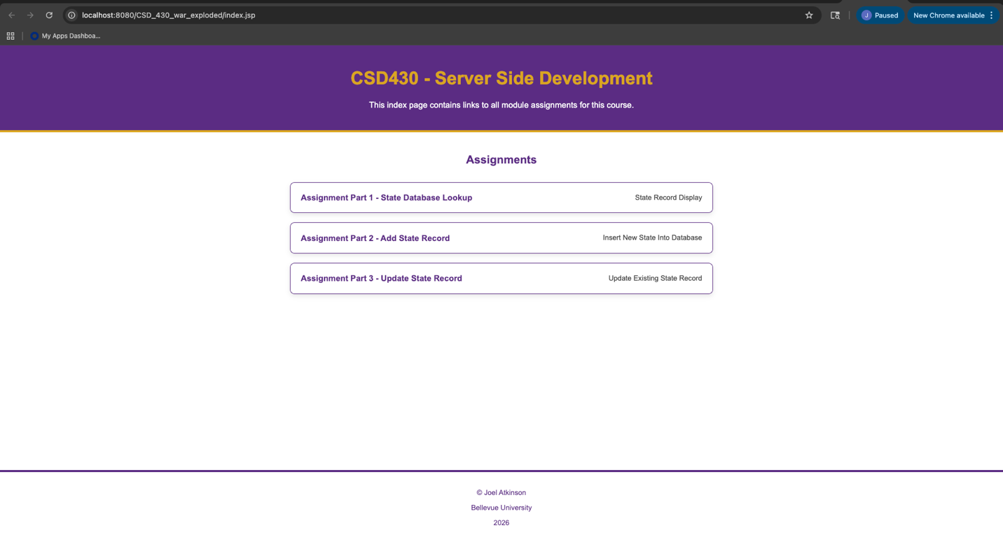
Screenshot of select state page:
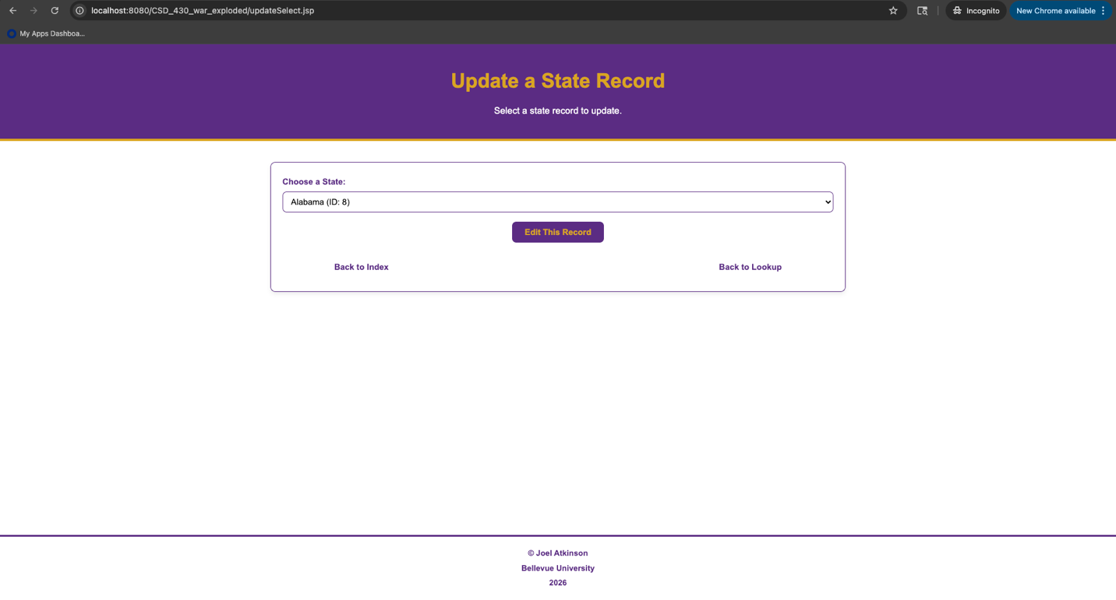
Screenshot of the update page with me entering in “Test” as the capital of Arizona to test that it works:
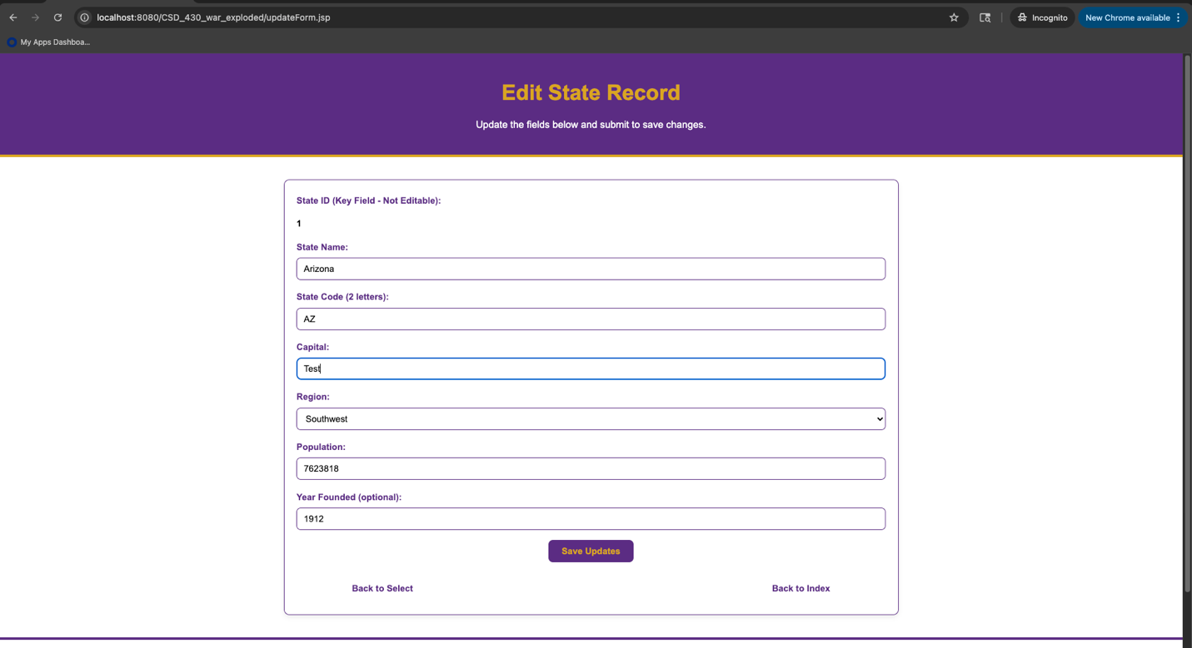
Screenshot of updated information displayed in a table:
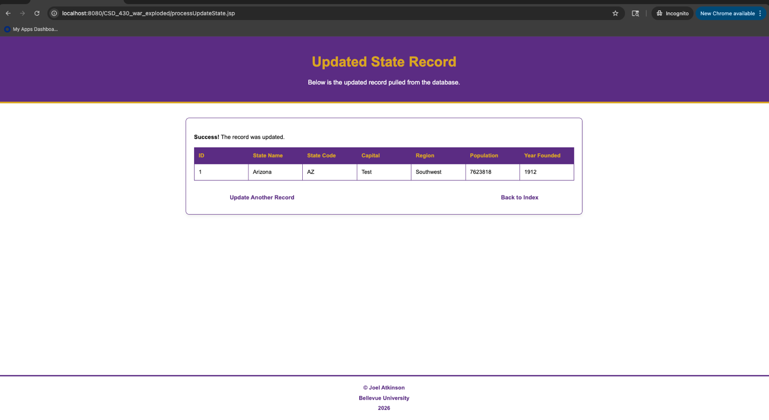
Screenshot of my SQL running and checking database to confirm that the change I made through this page actually adjusted the data in the database. As you can see, the capital of Arizona was changed to “Test” proving that it all worked as planned:
